**“Experiment – 6”**

Name: **SUMIT KUMAR** UID: **20BCS8226**

Branch: **BE-CSE** Section/Group: **MM 808 A**

Semester: **5th** Date of Submission: **23/10/22**

Subject Name: **Machine Learning Lab** Subject Code: **20CSP-317**

**1. Aim/Overview of the practical:**

Implement K-Nearest Neighbor on any data set.

**2. Task to be done/ Which logistics used:**

Implement K-Nearest Neighbor on any data set using sklearn.

**3. Steps for experiment/practical/Code:**

# Import necessary modules

from sklearn.neighbors import KNeighborsClassifier

from sklearn.model_selection import train_test_split

from sklearn.datasets import load_iris

# Loading data

irisData = load_iris()

# Create feature and target arrays

X = irisData.data

y = irisData.target

# Split into training and test set

X_train, X_test, y_train, y_test = train_test_split(

             X, y, test_size = 0.2, random_state=42)

knn = KNeighborsClassifier(n_neighbors=7)

knn.fit(X_train, y_train)

# Predict on dataset which model has not seen before

print(knn.predict(X_test))

# Import necessary modules

from sklearn.neighbors import KNeighborsClassifier

from sklearn.model_selection import train_test_split

from sklearn.datasets import load_iris

# Loading data

irisData = load_iris()

# Create feature and target arrays

X = irisData.data

y = irisData.target

# Split into training and test set

X_train, X_test, y_train, y_test = train_test_split(

             X, y, test_size = 0.2, random_state=42)

knn = KNeighborsClassifier(n_neighbors=7)

knn.fit(X_train, y_train)

# Calculate the accuracy of the model

print(knn.score(X_test, y_test))

# Import necessary modules

from sklearn.neighbors import KNeighborsClassifier

from sklearn.model_selection import train_test_split

from sklearn.datasets import load_iris

import numpy as np

import matplotlib.pyplot as plt

irisData = load_iris()

# Create feature and target arrays

X = irisData.data

y = irisData.target

# Split into training and test set

X_train, X_test, y_train, y_test = train_test_split(

             X, y, test_size = 0.2, random_state=42)

neighbors = np.arange(1, 9)

train_accuracy = np.empty(len(neighbors))

test_accuracy = np.empty(len(neighbors))

# Loop over K values

for i, k in enumerate(neighbors):

    knn = KNeighborsClassifier(n_neighbors=k)

    knn.fit(X_train, y_train)

    # Compute training and test data accuracy

    train_accuracy[i] = knn.score(X_train, y_train)

    test_accuracy[i] = knn.score(X_test, y_test)

# Generate plot

plt.plot(neighbors, test_accuracy, label = 'Testing dataset Accuracy')

plt.plot(neighbors, train_accuracy, label = 'Training dataset Accuracy')

plt.legend()

plt.xlabel('n_neighbors')

plt.ylabel('Accuracy')

plt.show()

**4. Result/Output/Writing Summary:**

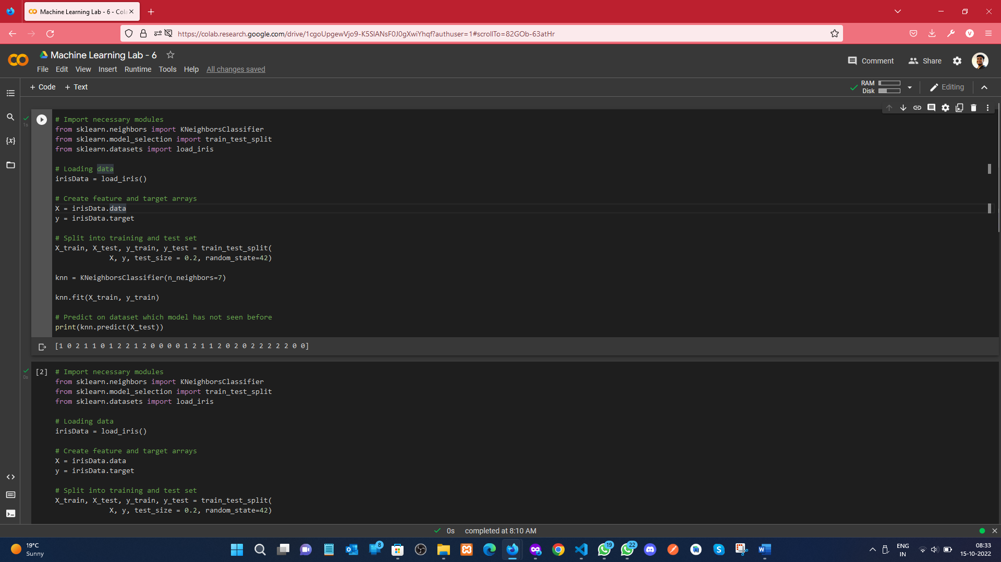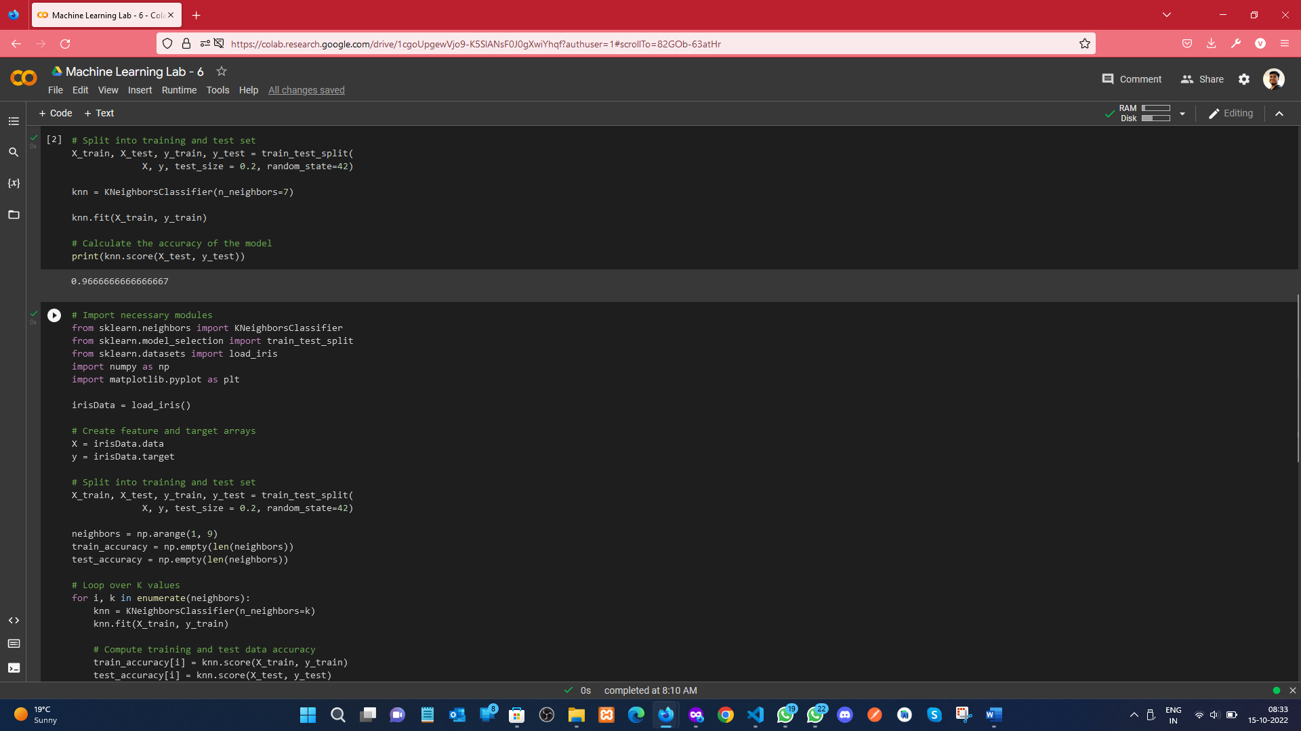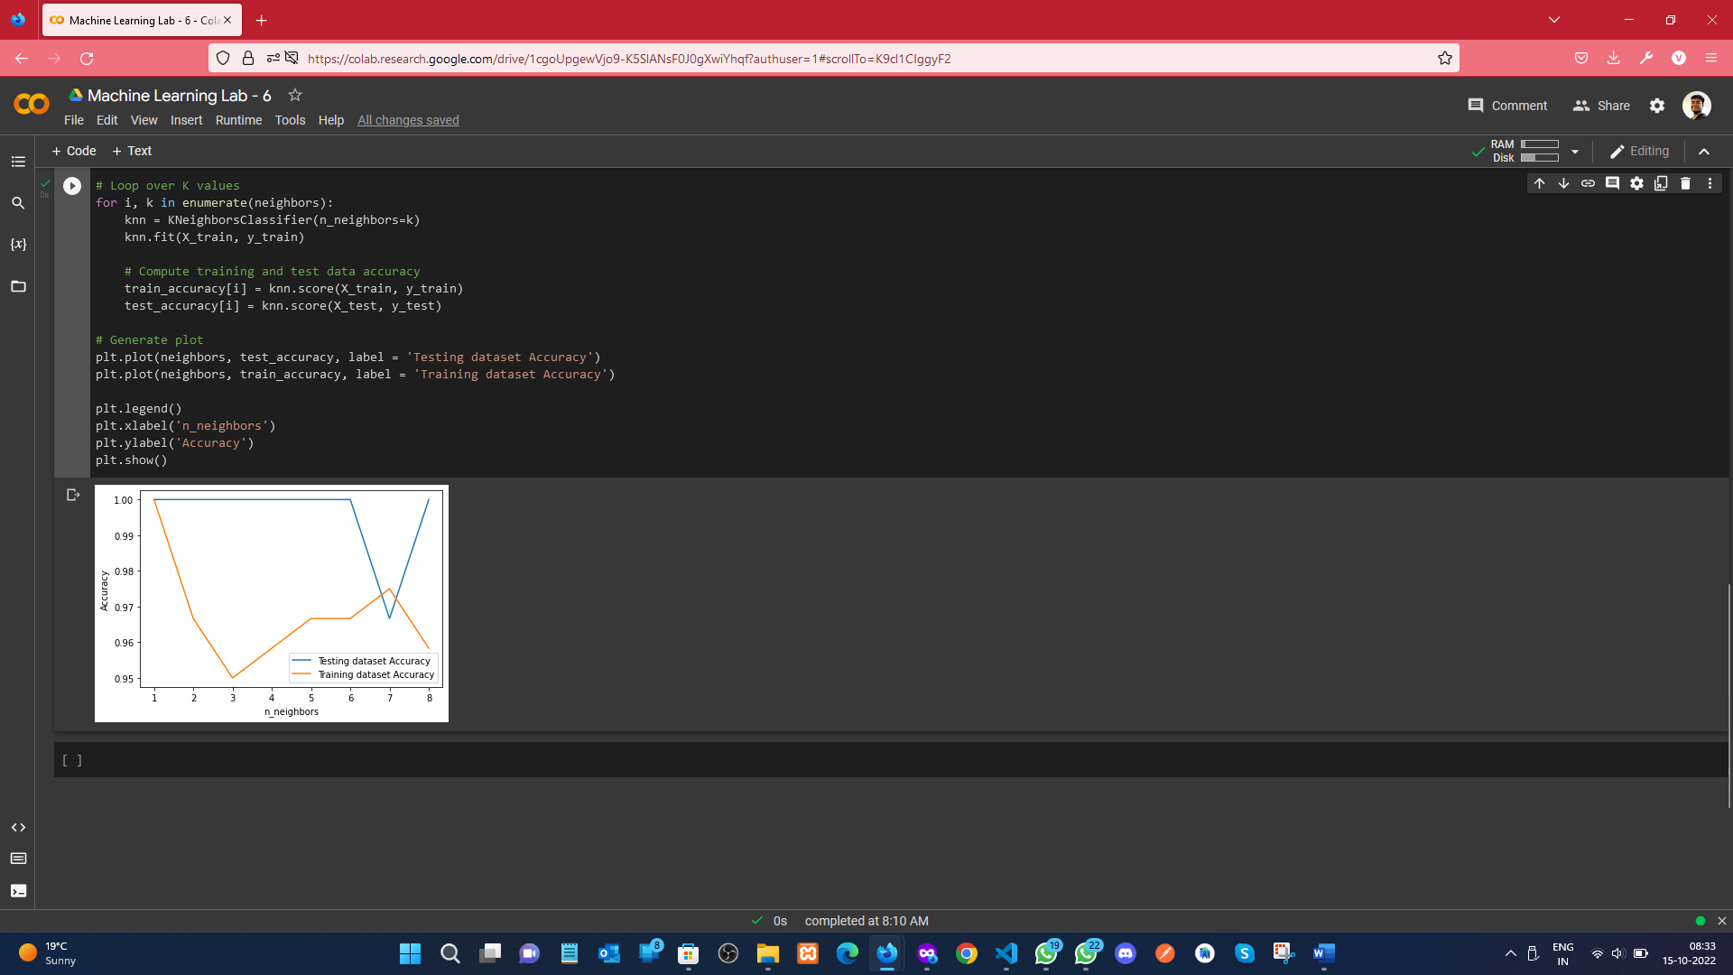

**Learning outcomes (What I have learnt):**

1. Understood the concept of KNeighborsClassifier.
2. Learnt how to load the iris dataset, and splitting the dataset.
3. Predicting the test data on KNN.
4. Plot the legend graph of Accuracy of the Dataset.

**Evaluation Grid (To be created as per the SOP and Assessment guidelines by the faculty):**

|  |  |  |  |
| --- | --- | --- | --- |
| Sr. No. | Parameters | Marks Obtained | Maximum Marks |
| 1. |  |  |  |
| 2. |  |  |  |
| 3. |  |  |  |
|  |  |  |  |